How to add an assignment in powerteacher

- Click on your gradebook and signin

- Click on the subject on the left side of the screen
- Then click on the + in the center of the page to Add Assignment

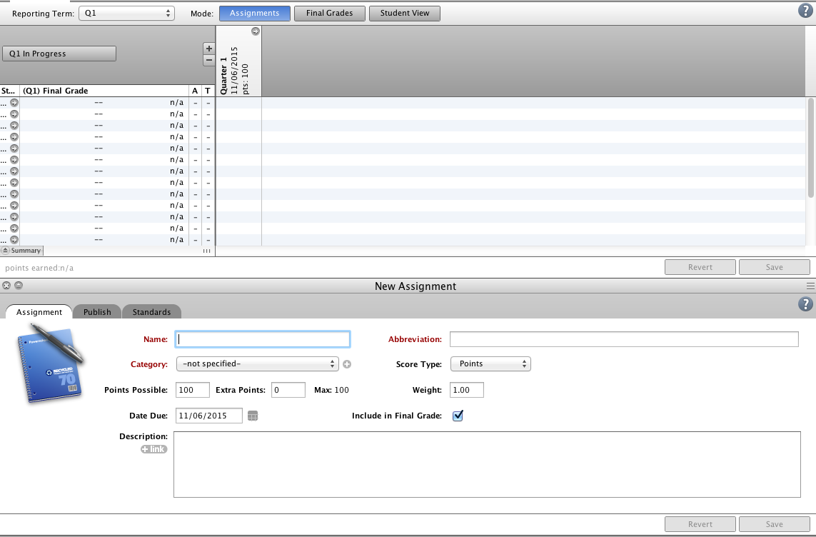

- Fill in the requirement fields at the bottom (Name, Category and Date Due) than click save
- This will create your assignment and just fill in your students scores.

